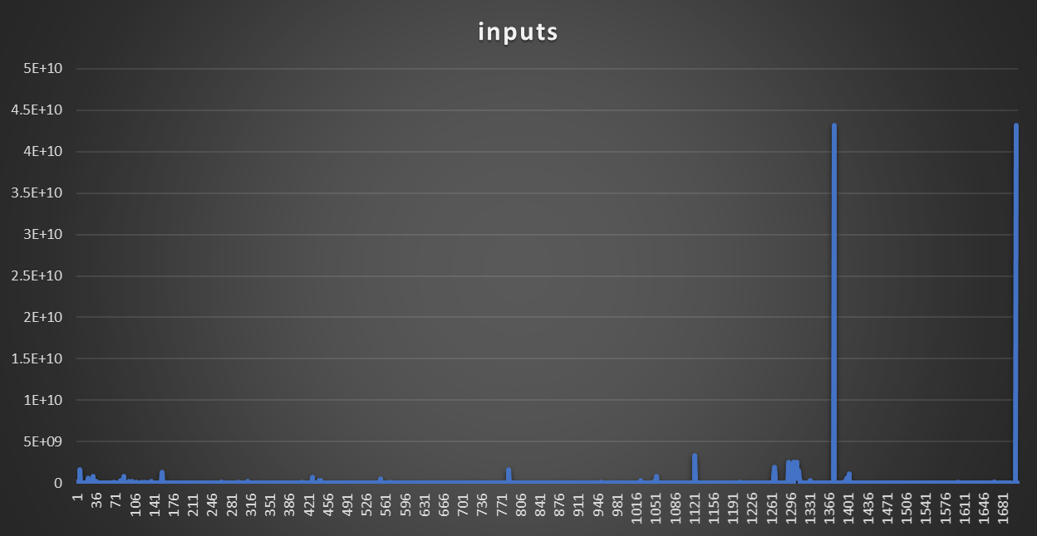

**Avg of the transactions : 57936845.09**

**Max input value is : 43119903723; address:** **3BBcr1ps4h8yX7U6wdbkdnks3NPJoeeLq7  
hash : a60d87388f658ee8f6f371ed6fff6f810bd12c31304f6b4f020f80a4e70b7061  
Output_O:** **1000000000; address: 33DxxXyh3nLYgYB1sM8VTPb7bipkonuhB4  
Output_1: 42119903055; address: 3DRdYoNeVrAYVDcN7rTTekfwT8K644Uwj7**

**Fee = 43119903723 – (1000000000 + 42119903055) = 668**

**Minimum input value is : 546; address: 1HpZ5uLZLufGnyYGhoMqdqZVsQRFghvNMq  
hash: f5d0a2be813539737145307fbbc47b14d551f5b046df2078e00708c62ec7de55  
output_0 = 546 ; address:**